Pupil premium strategy statement – Alkborough Primary Academy
2025-26
This statement details our school’s use of pupil premium (and recovery premium for the 2025 to 2026 academic year) funding to help improve the attainment of our disadvantaged pupils.
It outlines our pupil premium strategy, how we intend to spend the funding in this academic year and the effect that last year’s spending of pupil premium had within our school.
School overview
Detail | Data
School name | Alkborough Primary
Number of pupils in school | 47 FT 2 PP eligible
Proportion (%) of pupil premium eligible pupils | 4.2% 2/47
Academic year/years that our current pupil premium strategy plan covers (3 year plans are recommended) | 2025/26  2026/27  2027/28
Date this statement was published | December 2025
Date on which it will be reviewed | December 2026
Statement authorised by | Mr S Woolley
Pupil premium lead | Mr S Woolley
Governor / Trustee lead | Michelle Garlick

Funding overview
Detail | Amount
Pupil premium funding allocation this academic year | £ 7575
Recovery premium funding allocation this academic year | £0
Pupil premium funding carried forward from previous years (enter £0 if not applicable) | £0
Total budget for this academic year  If your school is an academy in a trust that pools this funding, state the amount available to your school this academic year | £ 7575
Part A: Pupil premium strategy plan
Statement of intent
At Alkborough Primary School we target the use of Pupil Premium Grant funding and to ensure that our disadvantaged pupils receive the highest quality of education to enable them to become Respectful, safe and kind Learners who are socially responsible citizens of the future.
We recognise that disadvantage can be caused by a wide range of things. These can be influenced through a lack of finance, but also a lack of cultural capital. Children can face a wide range of barriers which may impact on their learning. A lack of transport and experiences for the children caused by geographical isolation, the current economical situation within the country which leaves families stretched financially but earn enough to be above the threshold for claiming PP funding.
Our ultimate objectives are to:
- Remove barriers to learning created by poverty, family circumstance and background.
- Narrow the attainment gaps between disadvantaged pupils and their non-disadvantaged counterparts both within school and nationally.
- To ensure quality first teaching so that all children make good progress or better and catch up.
- Develop confidence in their ability to communicate effectively in a wide range of contexts.
- Enable pupils to look after their social and emotional well-being and to develop resilience.
- Access a wide range of opportunities to develop their knowledge and understanding of the world.
Our context:
- 4 % of pupils are eligible for Pupil Premium Funding

Background
Evidence shows that children from disadvantaged backgrounds generally face extra challenges in reaching their potential at school and often do not perform as well as their peers. Therefore, publicly funded schools in England receive additional funding (pupil premium) from the government to help overcome barriers to learning and improve the progress and outcomes of disadvantaged pupils.

Pupil premium funding based on the number of pupils in school in January each year from the following groups:
- Free school meals;
- Looked-after and previously looked-after children;
- Service premium - whilst paid to schools with the pupil premium the service premium is not part of the pupil premium and eligibility relates to pupils with a parent serving in HM Forces or in receipt of a pension from the Ministry of Defence. This funding is to help with pastoral support.
Non-eligible pupils
Schools may spend their pupil premium funding on pupils who do not meet the eligibility criteria but need additional support.
For example:
- are in contact with a social worker
- used to be in contact with a social worker
- are acting as a carer

Allocation of additional funding
At Alkborough Primary School we use the Education Endowment Foundation (EEF) Guide to Pupil Premium. This includes the following 5 key principles of spending:
- Schools can make a difference in narrowing attainment gaps;
- Evidence-informed teachers and leaders must combine research findings with professional expertise to make decisions;
- Quality First Teaching helps every child;
- Funding must support middle and higher attaining pupils – it must not solely focus on lower ability pupils;
- Focussing on a small number of carefully chosen priorities is effective - less can be more.

In line with the EEF Guide, Alkborough Primary School adopts a tiered approach to Pupil Premium spending. They are as follows:

Quality First Teaching
Ensuring an effective teacher is in front of every class, and that every teacher is supported to keep improving, is the key ingredient of a successful school and should rightly be the top priority for Pupil Premium spending. Spending on improving teaching might, but not exclusively, include professional development, training and support for early career teachers and recruitment and retention.

Targeted academic support
Evidence consistently shows the positive impact that targeted academic support can have, including on those who are not making good progress. Considering how classroom teachers and teaching assistants can provide targeted academic support, including how to link structured one-to-one or small group intervention to classroom teaching, is likely to be a key component of an effective Pupil Premium strategy. The EEF have evaluated the impact of a range of strategies and schools are encouraged to make use of these resources.

Wider strategies
Wider strategies relate to the most significant non-academic barriers to success in school, including attendance, behaviour and social and emotional support.

Challenges
This details the key challenges to achievement that we have identified among our disadvantaged pupils.

Challenge number | Detail of challenge
1 | Increased numbers of children needing speech and language interventions on entry to school/nursery.
2 | Sufficient high-quality staffing to provide impactful interventions and to support smooth, successful pupil transitions to their next learning key stage.
3 | Focus on reading for disadvantaged pupils through use of phonics to support them in accessing the full curriculum
4 | Development of writing across the academy through the development of high-quality teaching and moderation to support disadvantaged learners to make good progress
5 | Ensuring that all children have high quality curriculum access, not being limited by home situations
6 | Targeted use of Thrive intervention allowing early intervention where required
7 | Access to mental health and wellbeing support for pupils who need it in a timely manner, including development of in-house approaches

Intended outcomes
This explains the outcomes we are aiming for by the end of our current strategy plan, and how we will measure whether they have been achieved.
Intended outcome | Success criteria
Gaps in pupils' learning are identified in reading, writing, spelling & maths and quality first teaching and interventions are adapted and targeted to address these. | - Formative assessments will show gaps are being addressed and pupils are making expected progress (or exceeding).  - Effective early interventions and teacher targeting are in place to challenge previously exceeding children and accelerate progress of children with potential.  - Individual support plans will be formulated for those pupils with additional needs and targets, strategies and progress will be reviewed, discussed and shared with the pupil and parents.  - Progress will be monitored termly.
Close the gap and improve progress in reading for disadvantaged pupils. | - Achieve outcomes in-line with, or above, national average by the end of KS1 & KS2 in reading and writing.  - Effective early interventions and teacher targeting are in place to challenge previously exceeding children and accelerate progress of children with potential.  - Individual support plans will be formulated for those pupils with additional needs and targets, strategies and progress will be reviewed, discussed and shared with the pupil and parents, with regards to reading (where applicable)  - Across the school, pupils have access to a range of quality reading materials in class libraries and gain an interest in reading for pleasure, developed from high quality phonics & reading lessons with a focus on fluency & class discussion to build comprehension skills.  - Use of Accelerated reader to ensure tracking of all children throughout the academy
Close the gap and improve progress in writing (including handwriting) for disadvantaged pupils. | - Achieve outcomes in-line with, or above, national average by the end of KS1 & KS2 in and writing.  - Effective early interventions and teacher targeting are in place to challenge previously exceeding children and accelerate progress of children with potential.  - Individual support plans will be formulated for those pupils with additional needs and targets, strategies and progress will be reviewed, discussed and shared with the pupil and parents, with regards to writing (where applicable)
In EYFS, pupils are supported in developing social, emotional, communication and language skills in order to transition into:  - F1  - F2  and access learning.  Pupils in KS1, are supported in developing social, emotional, communication and language skills.  Pupils in KS2, are supported in developing social, emotional, communication and language skills | - To secure quality first teaching for disadvantaged pupils with identified communication and language needs.  - The EYFS curriculum & environment supports the development of social, emotional, communication and language skills  - Disadvantaged pupils with communication & language needs in EYFS, KS1 & KS2 are identified by class teachers & liaison with SENDCO & outside agencies.  - Disadvantaged children with underdeveloped language receive targeted intervention to accelerate progress.  - Children who receive targeted intervention for speech, communication & language, make the expected progress and maintain progress, post intervention.  - Targeted support from leaders and school based interventions for all year groups including early support for new starters is effective.
Maintain positive outcomes in maths for disadvantaged pupils, including SEN and more able pupils. | - Achieve outcomes in-line with, or above, national average by the end of KS1 & KS2.  - Pupils’ gaps in learning are identified and arithmetic skills are focused on during class time and within targeted intervention & support time to maintain progression and positive outcomes.  - Gaps in other core areas of maths are identified and addressed during lessons, 1-1 support and interventions  - Individual support plans will be formulated for those pupils with additional needs and targets, strategies and progress will be reviewed, discussed and shared with the pupil and parents, with regards to maths (where applicable)
Support pupils’ emotional and physical well-being, resilience and self-esteem, in order that they access and engage positively in their learning. | - Pupils engage well in lessons and achieve outcomes in-line with or above national average by the end of KS1 & KS2.  - Early Help supports individual pupils and parents and pupils engage positively in lessons.  - PP pupils have equal opportunities and pupils have positive aspirations and make good life choices & behaviour is good.  - Children are accessing the curriculum in a positive and mindful way.  - Children create management techniques to ensure they utilise learning time  - Focus on mental well-being is effective.
Pupils are afforded opportunities to experience a wide range of social/cultural and sporting experiences. | - Pupils given opportunities for outdoor learning and well-being and resilience is improved.  - Pupils attend school trips to visit places they otherwise would not.  - Pupils are exposed to enrichment activities and sporting events.  - Pupils are enthusiastic for learning through the delivery of an exciting and engaging curriculum, whilst also providing opportunities for learning in different contexts impacting positively on pupil engagement and pupil outcomes.
Attendance. | - Ensure attendance of disadvantaged pupils is at least 96%.  - Support plans put in place, where required, to support parents and improve attendance.
Activity in this academic year
This details how we intend to spend our pupil premium this academic year to address the challenges listed above.
Teaching (for example, CPD, recruitment and retention)
Budgeted cost: £ 4000

Activity | Evidence that supports this approach | Challenge number(s) addressed
Higher child to adult ratio Year 2 and Reception to ensure that all children can make rapid progress and develop the skills required to access the next Key Stage in their development and in Year 6 where appropriate | EEF – Provide High Quality Feedback +6mths  EEF - Social and emotional learning - +4mths  EEF Small group tuition – +4mths | 2, 7
Ensure that there is high quality teaching and support groups for phonics. | EEF Oral Language interventions +6mths  EEF Phonics - +5mths | 1, 3
Support Y6 teacher in training to be a Local Authority moderator and ensuring that best practice is brought back into the academy for both reading and writing | EEF Reading comprehension strategies +6mth | 1, 3, 4

Targeted academic support (for example, catch up, one-to-one support structured interventions)
Budgeted cost: £ 2750
Activity | Evidence that supports this approach | Challenge number(s) addressed
Ensure training and staffing for high quality Speech and Language intervention program is available where appropriate | EEF Oral Language interventions +6mths | 1
Develop high quality interventions across the academy including: Phonics, precision teaching and 5 min box to name a few | EEF Oral Language interventions +6mths  EEF Phonics - +5mths  EEF Teaching assistant interventions +4mths | 1, 2, 3, 4
Ensure that where children require Thrive intervention they are able to access it in a timely manner allowing them to then confidently access the curriculum | EEF Tool Kit – Metacognition and Self-Regulation +7mths  EEF Tool Kit – Social and emotional learning +4mths | 6, 7
Support the ongoing work with, With Me in Mind to ensure all children that require intervention with mental health receive it. | EEF Tool Kit – Metacognition and Self-Regulation +7mths  EEF Tool Kit – Social and emotional learning +4mths | 6, 7

Wider strategies (for example, related to attendance, behaviour, wellbeing)
Budgeted cost: £ 1100
Activity | Evidence that supports this approach | Challenge number(s) addressed
Develop health and wellbeing strategies across the academy through use With me in Mind and Thrive | EEF Tool Kit – Metacognition and Self-Regulation +7mths  EEF Tool Kit – Social and emotional learning +4mths | 6, 7
Ensure that all children have access to all areas of the curriculum regardless of their financial position through subsidising visits / residentials / providing access to after school clubs and enhancement activities for all children. | EEF Arts Participation +3mths  EEF Physical activity - +1mth | 4, 5
Support access to peripatetic music teaching to enhance curriculum experience | EEF Arts Participation +3mths | 5
Provide access to specialist teaching to enhance the experience of subjects | EEF Arts Participation +3mths | 5

Total budgeted cost: £
Part B: Review of outcomes in the previous academic year
Pupil premium strategy outcomes
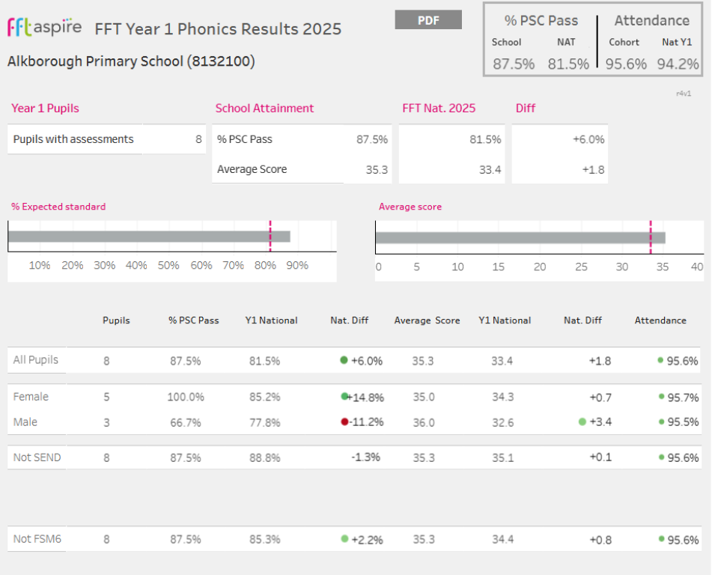
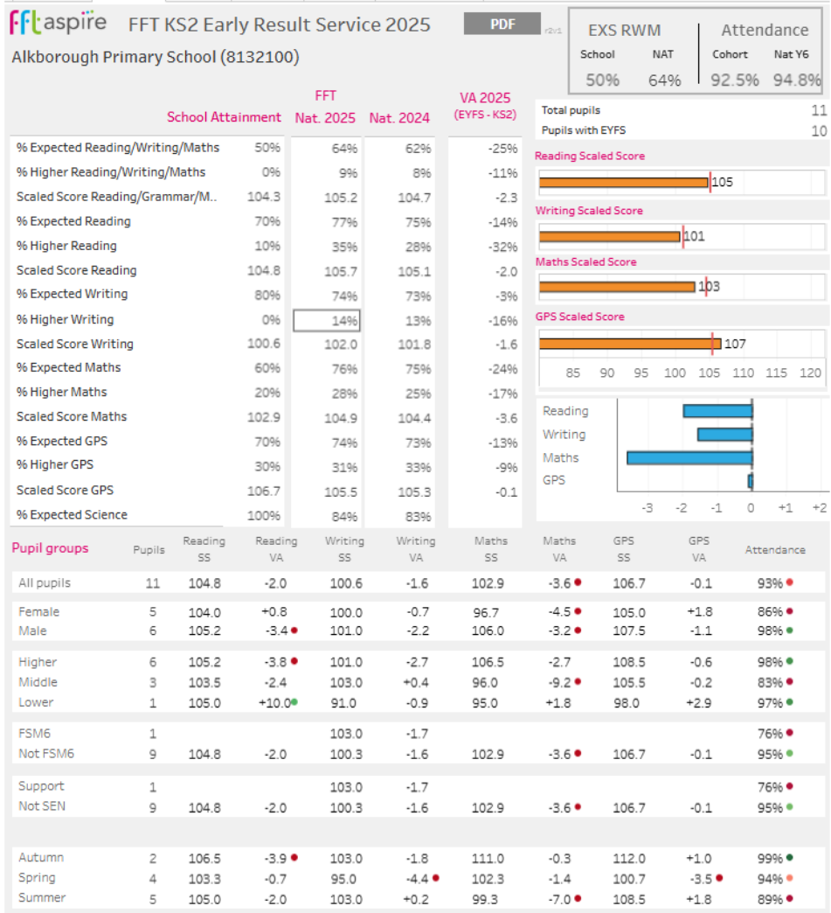

Externally provided programmes
Please include the names of any non-DfE programmes that you purchased in the previous academic year. This will help the Department for Education identify which ones are popular in England
Programme | Provider
Thrive | Emotionally Friendly Schools
SALT | Speech and Language
PE Mentor
Service pupil premium funding (optional)
For schools that receive this funding, you may wish to provide the following information:
N/A

